1. **Control algorithm for dosing nitrate in sewers**

* 1. **Background**

Nitrate salts have been used over the last 70 years to control odours and sulfide production in many environments. Nitrate works by the biological oxidation of H2S to SO42- by means of nitrate reducing-sulfide oxidising bacteria (NR-SOB). Nitrate does not have any inhibitory effect over SRB. Nitrate can be used by heterotrophic bacteria to oxidise organic matter, which would increase nitrate consumption.

|  |
| --- |
| Further information can be obtained as follows:   * Effects of nitrate dosing:   + **Paper:** *Mohanakrishnan, J., Gutierrez, O., Sharma, K.R., Guisasola, A., Werner, U., Meyer, R.L., Keller, J. and Yuan, Z. (2009) Impact of nitrate addition on biofilm properties and activities in rising main sewers. Water Research 43(17), 4225-4237.*   + **Paper:** *Jiang, G., Sharma, K.R., Guisasola, A., Keller, J. and Yuan, Z. (2009) Sulfur transformation in rising main sewers receiving nitrate dosage. Water Research 43(17), 4430-4440.* |

* 1. **Control Strategy**
     1. **Dosing Location**

A suitable location for nitrate dosing (*x*) can be theoretically determined from Equation 1.

 (1)

Where *D* is the pipe diameter (m), *L* is the pipe length (m), *rB* the sulfide production rate of the biofilm (gS/m2▪d), *rB,ox* the biological sulfide oxidation rate of the biofilm (gS/m2▪d), *TDS0* the total dissolved sulfide at the beginning of the rising main (g/m3), *TDSf* the total dissolved sulfide at the end of the rising main (g/m3) and QL is the sewage flow (m3/d).

* + 1. **Dosing rate**

Assuming a nitrate dosing station located in a downstream section, close to the rising main discharge point, nitrate dosage for an optimised dosing depend on two factors:

* The amount of sulfide produced upstream that needs to be oxidised
* The nitrate that will be consumed by heterotrophic bacteria during the transport time between the dosing location and the discharge/control point.
  + - 1. *Sulfide produced upstream*

The amount of nitrate required for sulfide oxidation to sulfate is 0.7gN-NO3-/gS-H2S according to equation 2.

$5H_{2}S + 8{NO}_{3}^{-} 5{SO}_{4}^{2-} + 4N_{2} + 2H^{+}+ 4H_{2}O$ (2)

Sulfide concentration at the dosing location can be measured using a S::CAN UV/VIS spectrometer. If online measurement is unavailable, typical sulfide profiles can be estimated based on HRT as illustrated in Figure 1.

HRT_TDS.TIF

Figure 1. Total dissolved sulfide vs. hydraulic retention time. Field data from UC09 (Allconnex Water).

* + - 1. *Heterotrophic nitrate consumption downstream*

Nitrate consumption rate by heterotrophic bacteria can be modelled using a Monod kinetic according to the following equation:

 (3)

Where *rarea* is heterotrophic nitrate consumption rate of the biofilm (mg N/L); *rarea,max* is the maximum nitrate consumption rate of the biofilm;  is the concentration of nitrate in the boundary layer of biofilm (mg N/L) and  is the half-saturation substrate limitation constant for nitrate in the biofilm.

For a given pipe diameter and retention time, the amount of nitrate to be dosed to reach the desired concentration at the discharge point can be estimated by equation 3 using a Newton iteration method.

Due to the intermittent operation pattern of sewer pumping stations, the effects of quiescent periods on nitrate consumption rate is also taken into consideration (Figure 2).

quiescent.TIF

Figure 2. Pumping profile, HRT downstream and activity corrected by quiescent conditions.

* + - 1. *Future flow prediction*

The heterotrophic nitrate consumption depends on the time the wastewater will be spending in the last section of the pipe. This can be estimated using typical HRT profiles (simple). Otherwise, future flow can be predicted based on ARMA models.

* + - 1. *Feedback Loop*

A feedback loop could be implemented to adjust the dosing based on weekly average nitrate concentration at the discharge point. This would require additional instrumentation to measure nitrate online.

* + 1. **Control scheme**

The control algorithm for the optimised dosing of nitrate is composed of a feedforward and a feedback loop. The feedforward loop will predict the amount of nitrate required to oxidise sulfide produced upstream the dosing location and ensure anoxic conditions of sewage until its discharge. Future HRT will be predicted by the ARMA model using the current flow measurements. In addition, the feedback loop can adjust the dosing based on the overall performance. A scheme of the control algorithm is depicted in Figure 3.

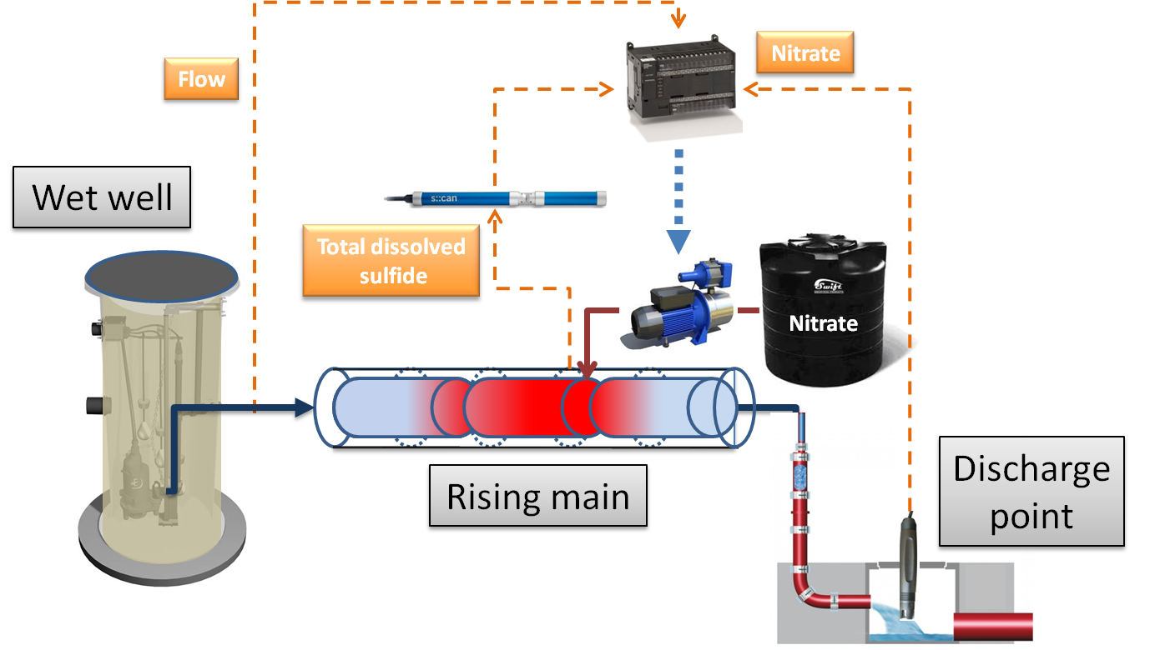

Figure 3. Control algorithm scheme for nitrate dosing.

* 1. **Case studies**

Nitrate dosing in the Clifton Springs sewer system (Barwon water) in Geelong, Australia